
COMPUTER SCIENCE AND ENGINEERING
Oct – 2026
ASSIGNMENT – 1
Course Code : CSA4316
Course Name : INTERNET PROGRAMMING
Name : Narravula Navya Sri
Reg No. : 192324220
Max Marks: 50
Answer all the Questions

1 | Analyze using a case study the fundamental concepts of website development, HTML5 document structure, semantic elements and the important features introduced in HTML5. | (10) | (CO1) | (BL3)
2 | A Professional photogragraper creates a static web page with inline, embedded and external CSS with ingredients of CSS cascading rules, specificity and inheritance with real time web . | (10) | (CO1) | (BL3)
3 | Using a Go Daddy website template as a reference, explain how CSS3 features are used to design modern web pages. Discuss backgrounds, border images, colors, shadows and text effects with suitable CSS code examples | (10) | (CO1) | (BL3)
4 | Design a Contemporary web page design with implementation of CSS3 transformations, transitions and animations (marquee) with different types of transformations and demonstrate how animations can be implemented using key frames. | (10) | (CO1) | (BL3)
5 | Design an architecture, features and working principles of Progressive Web Applications (PWA). Discuss the roles of service workers, web app manifests, caching strategies and push notifications in providing an enhanced user experience. | (10) | (CO1) | (BL3)

1. Analyze Using a Case Study the Fundamental Concepts of Website Development, HTML5 Document Structure, Semantic Elements and Important Features Introduced in HTML5.

Introduction
Website development is the process of creating and maintaining websites. It involves designing web pages, writing code, adding content and making websites interactive.
HTML5 (HyperText Markup Language 5) is the latest major version of HTML. It provides a standard structure for creating modern websites and supports multimedia, graphics and semantic elements.

Case Study: Online Shopping Website
Consider an online shopping website like Amazon. It allows users to view products, search for items, add products to a cart and make purchases.

1. Fundamental Concepts of Website Development
The main concepts are:
1. HTML (Structure)
- HTML is used to create the basic structure of a webpage.
- It defines headings, paragraphs, images, links and forms.
2. CSS (Presentation)
- CSS is used to style webpages.
- It controls colors, fonts, layouts, borders and spacing.
3. JavaScript (Functionality)
- JavaScript makes webpages interactive.
- It provides features such as search, form validation and shopping cart updates.
4. Web Hosting
- Web hosting stores website files on a server.
- Users can access the website through the internet.
5. Domain Name
- A domain name is the address of a website.
- Example: www.amazon.com.

2. HTML5 Document Structure
HTML5 provides a standard structure for webpages.
Example:
<!DOCTYPE html>
<html>
<head>
<title>Online Shopping</title>
<meta charset="UTF-8">
</head>

<body>

<header>
<h1>Online Shopping Store</h1>
</header>

<nav>
<a href="#">Home</a>
<a href="#">Products</a>
<a href="#">Contact</a>
</nav>

<main>
<section>
<h2>Featured Products</h2>
<p>Explore our latest products.</p>
</section>

<article>
<h2>Mobile Phone</h2>
<p>Latest smartphone at an affordable price.</p>
</article>
</main>

<footer>
<p>Copyright 2026</p>
</footer>

</body>
</html>

3. HTML5 Semantic Elements
Semantic elements clearly describe the meaning of webpage content.
Important semantic elements:
Element | Purpose
<header> | Defines the header section
<nav> | Defines navigation links
<main> | Contains the main content
<section> | Groups related content
<article> | Represents independent content
<aside> | Contains additional information
<footer> | Defines the footer section
<figure> | Groups images or illustrations
<figcaption> | Provides a caption for an image
Advantages of semantic elements:
- Improve website readability.
- Help search engines understand webpage content.
- Improve accessibility.
- Make code easier to maintain.
- Provide a clear webpage structure.

4. Important Features Introduced in HTML5
1. Audio Support
HTML5 provides the <audio> element to play audio without external plugins.
<audio controls>
<source src="music.mp3" type="audio/mpeg">
</audio>
2. Video Support
The <video> element is used to play videos.
<video width="400" controls>
<source src="movie.mp4" type="video/mp4">
</video>
3. Canvas
The <canvas> element is used to draw graphics using JavaScript.
<canvas id="myCanvas" width="200" height="100">
</canvas>
4. Improved Forms
HTML5 introduced new input types such as:
- Email
- Date
- Number
- Range
- URL
- Telephone
Example:
<form>
Email:
<input type="email" required>

<input type="submit">
</form>
5. Geolocation
HTML5 supports location-based applications through the Geolocation API.
6. Local Storage
Local storage allows websites to store data in the browser.
Example:
localStorage.setItem("username", "Ravi");

Conclusion
HTML5 plays an important role in modern website development. Its semantic elements, multimedia support, improved forms, canvas and local storage make websites more interactive, accessible and user-friendly.
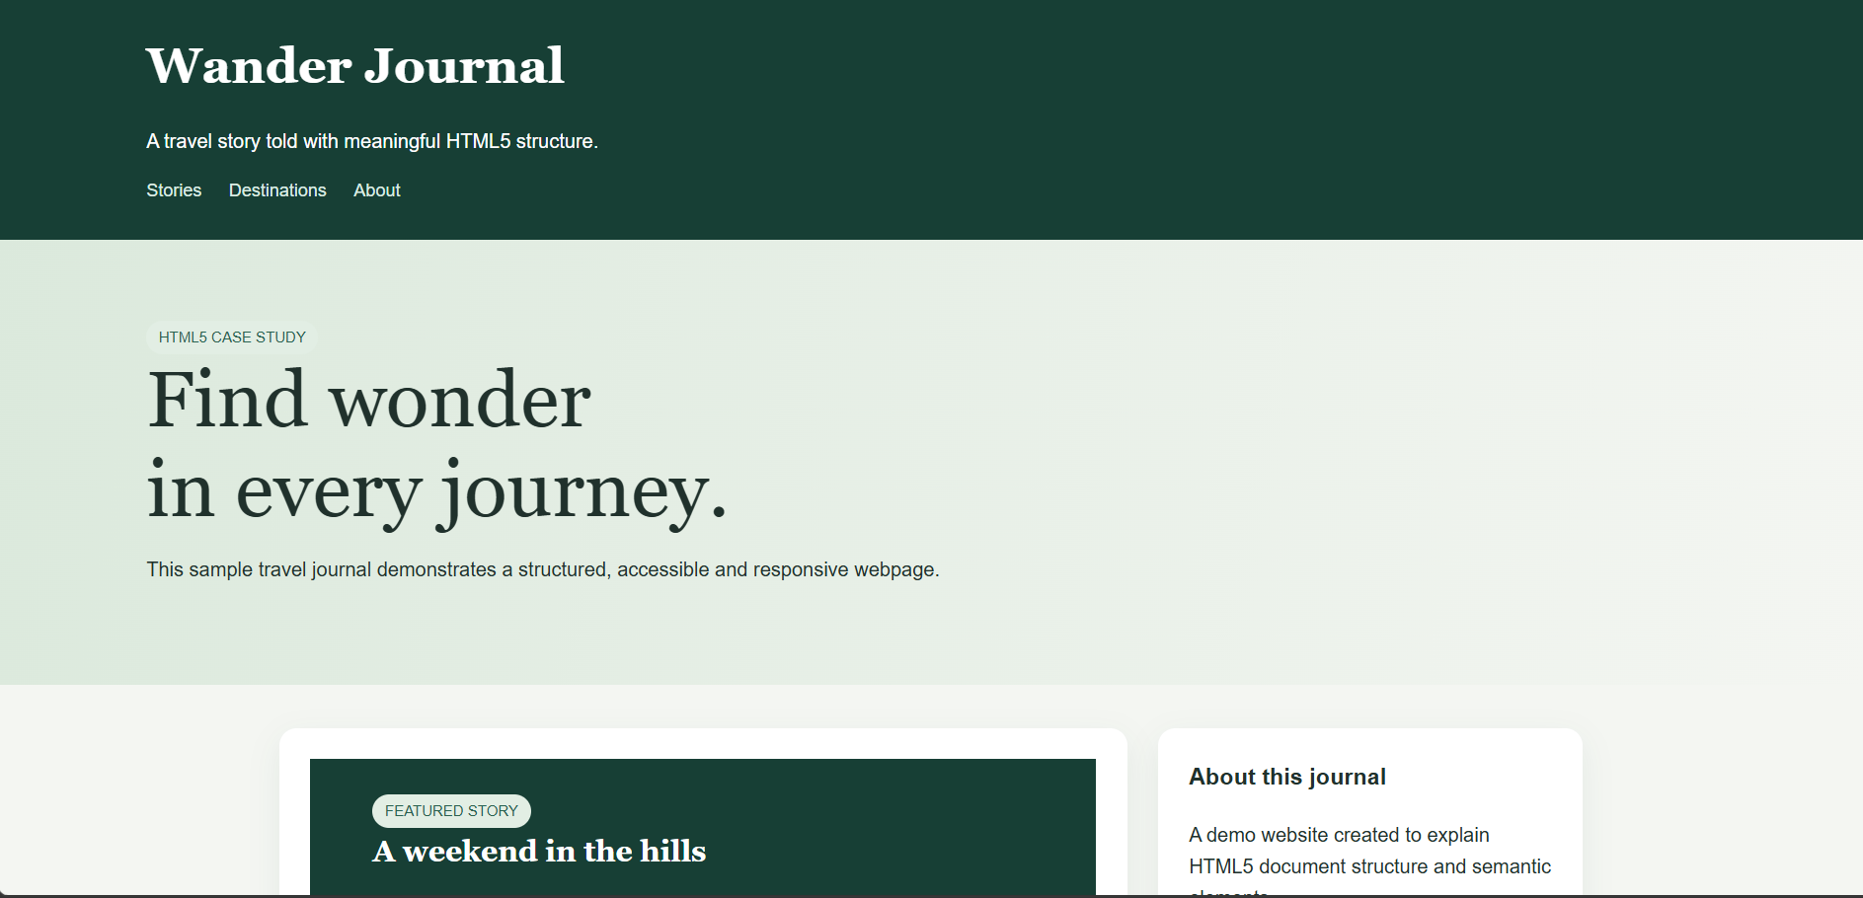
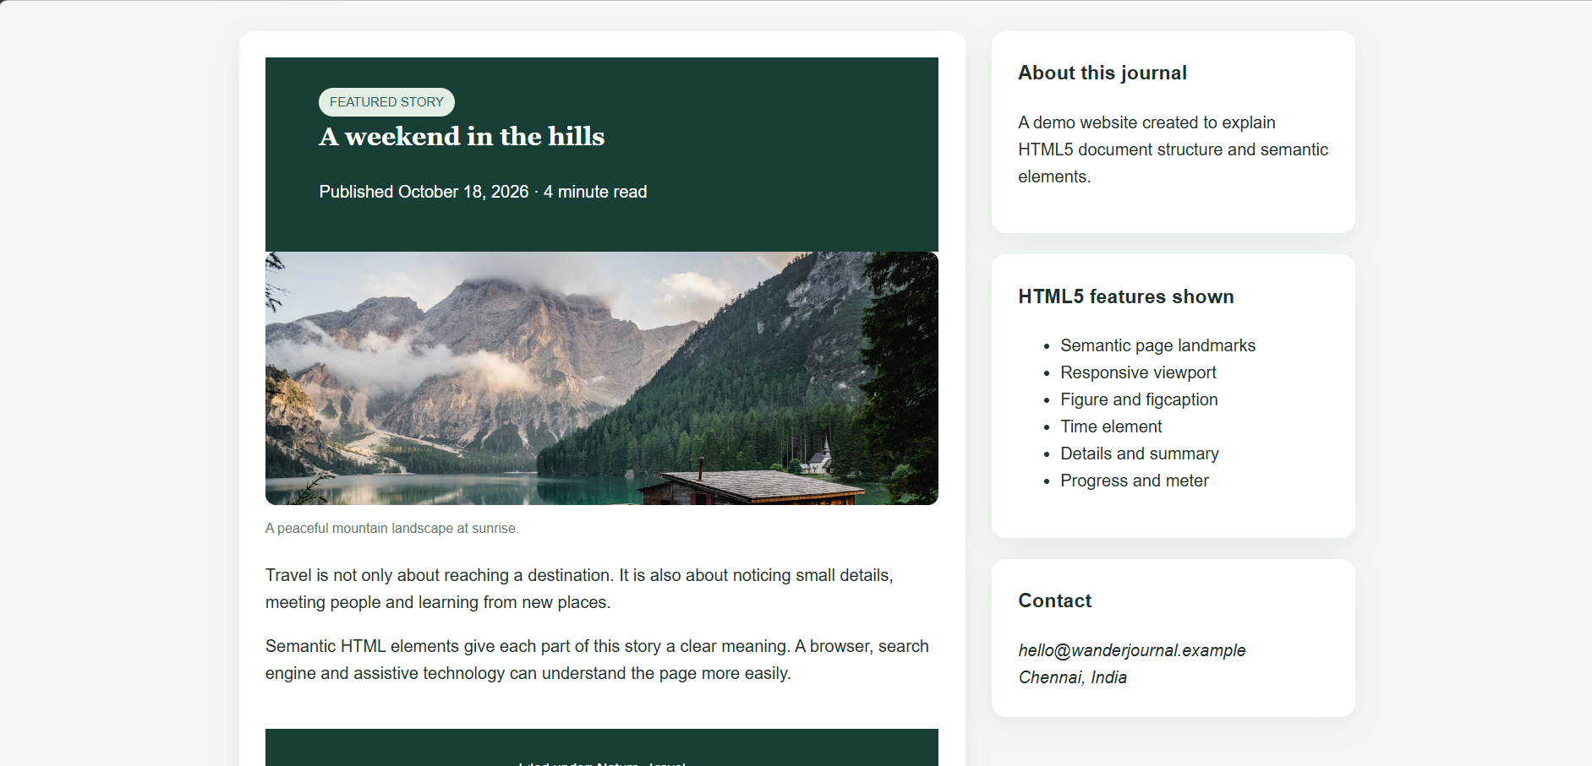

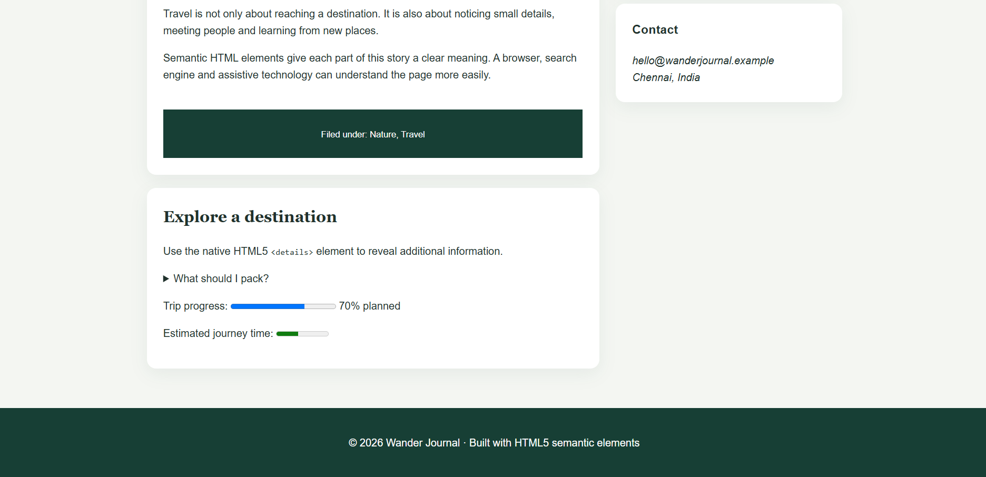

2. A Professional Photographer Creates a Static Web Page with Inline, Embedded and External CSS with Ingredients of CSS Cascading Rules, Specificity and Inheritance with Real-Time Web Examples.

Introduction
CSS (Cascading Style Sheets) is used to design and style HTML webpages. It controls colors, fonts, backgrounds, layouts, spacing and borders.
A professional photographer can use CSS to create an attractive portfolio website to display photographs, introduce services and provide contact information.

Case Study: Photographer Portfolio Website
A photographer wants to create a static website containing:
- Home page
- About the photographer
- Photography gallery
- Services
- Contact details
CSS can be applied in three different ways.

1. Inline CSS
Inline CSS is written directly inside an HTML element using the style attribute.
Example:
<h1 style="color: blue; text-align: center;">
My Photography Portfolio
</h1>
Advantages:
- Easy to apply.
- Useful for styling individual elements.
- Does not require a separate CSS file.
Disadvantages:
- Difficult to maintain.
- Cannot be reused easily.
- Makes HTML code lengthy.

2. Internal or Embedded CSS
Internal CSS is written inside the <style> element in the HTML document's <head> section.
Example:
<!DOCTYPE html>
<html>
<head>
<title>Photography Portfolio</title>

<style>
body {
background-color: lightgray;
font-family: Arial;
}

h1 {
color: darkblue;
text-align: center;
}

p {
color: black;
}
</style>
</head>

<body>

<h1>Professional Photography</h1>
<p>Capturing beautiful moments.</p>

</body>
</html>
Advantages:
- Suitable for a single webpage.
- Easy to manage styles within one file.
- No separate CSS file is required.
Disadvantages:
- Cannot be shared easily across multiple webpages.
- Increases HTML file size.

3. External CSS
External CSS is stored in a separate .css file and connected to HTML using the <link> element.
HTML file (index.html):
<!DOCTYPE html>
<html>
<head>
<title>Photography Website</title>

<link rel="stylesheet" href="style.css">
</head>

<body>

<h1>My Photography Gallery</h1>

<p>Welcome to my photography world.</p>

</body>
</html>
CSS file (style.css):
body {
background-color: white;
font-family: Arial;
}

h1 {
color: darkblue;
text-align: center;
}

p {
color: gray;
font-size: 18px;
}
Advantages:
- Easy to maintain.
- Can be reused across multiple webpages.
- Keeps HTML and CSS separate.
- Improves consistency.

4. CSS Cascading Rules
The cascading mechanism determines which CSS rule is applied when multiple rules target the same element.
The important factors include:
- Importance of the declaration (!important).
- CSS origin and cascade layer.
- Selector specificity.
- Source order.
Example:
h1 {
color: red;
}

h1 {
color: blue;
}
Output: The heading appears blue because the second rule comes later and has the same specificity.

5. CSS Specificity
Specificity determines which selector has higher priority.
General selector priority:
Selector | Example | Specificity
Universal | * | 0
Element | h1 | 0,0,1
Class | .title | 0,1,0
ID | #heading | 1,0,0
Inline style | style="color:red" | Higher than normal selector rules
Example:
<h1 id="heading" class="title">
Photography
</h1>
h1 {
color: red;
}

.title {
color: blue;
}

#heading {
color: green;
}
Output: Green, because the ID selector has higher specificity than the class and element selectors.

6. CSS Inheritance
Inheritance means some CSS properties are automatically passed from parent elements to their child elements.
Example:
body {
color: blue;
font-family: Arial;
}
The child elements generally inherit the text color and font family unless another rule overrides them.
Common inherited properties:
- Color
- Font family
- Font size
- Line height
Properties such as margin, padding and border are generally not inherited.

Real-Time Application
In a photographer's website:
- Inline CSS can highlight a special photograph.
- Internal CSS can style a single gallery page.
- External CSS can maintain a consistent design across the entire portfolio.
- Specificity can control important headings and gallery elements.
- Inheritance can maintain consistent typography.

Conclusion
CSS is essential for creating attractive and professional websites. Inline, internal and external CSS provide different styling methods, while cascading rules, specificity and inheritance help browsers determine how styles are applied.
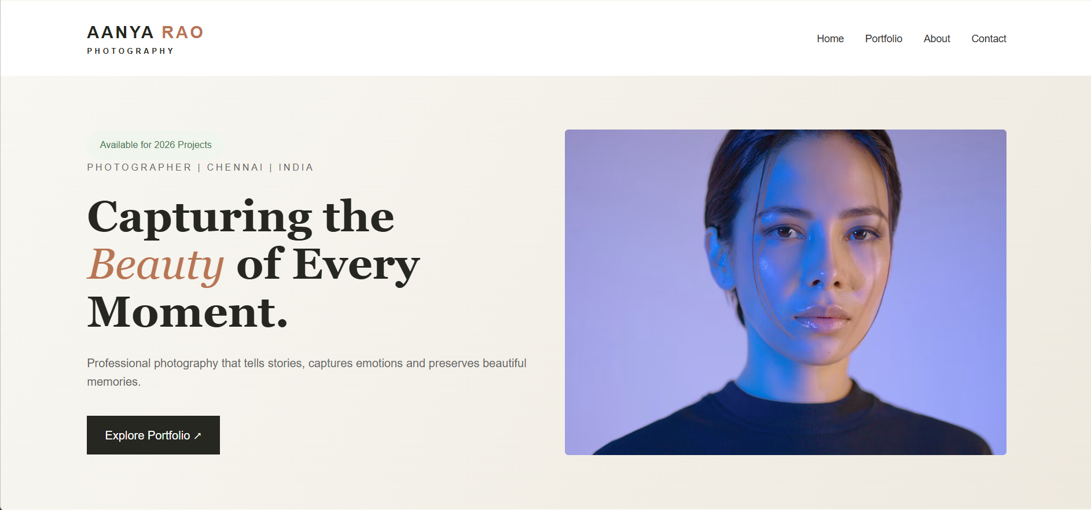

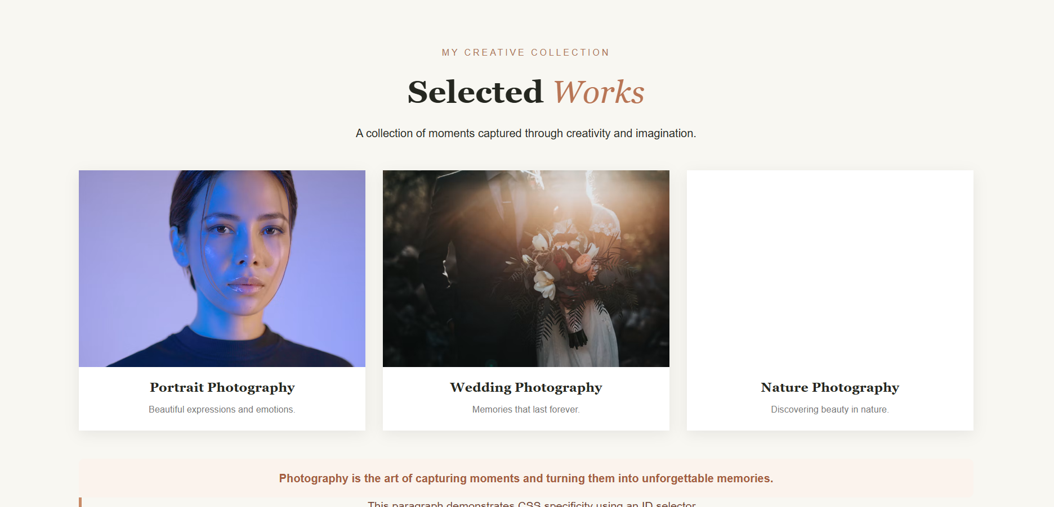
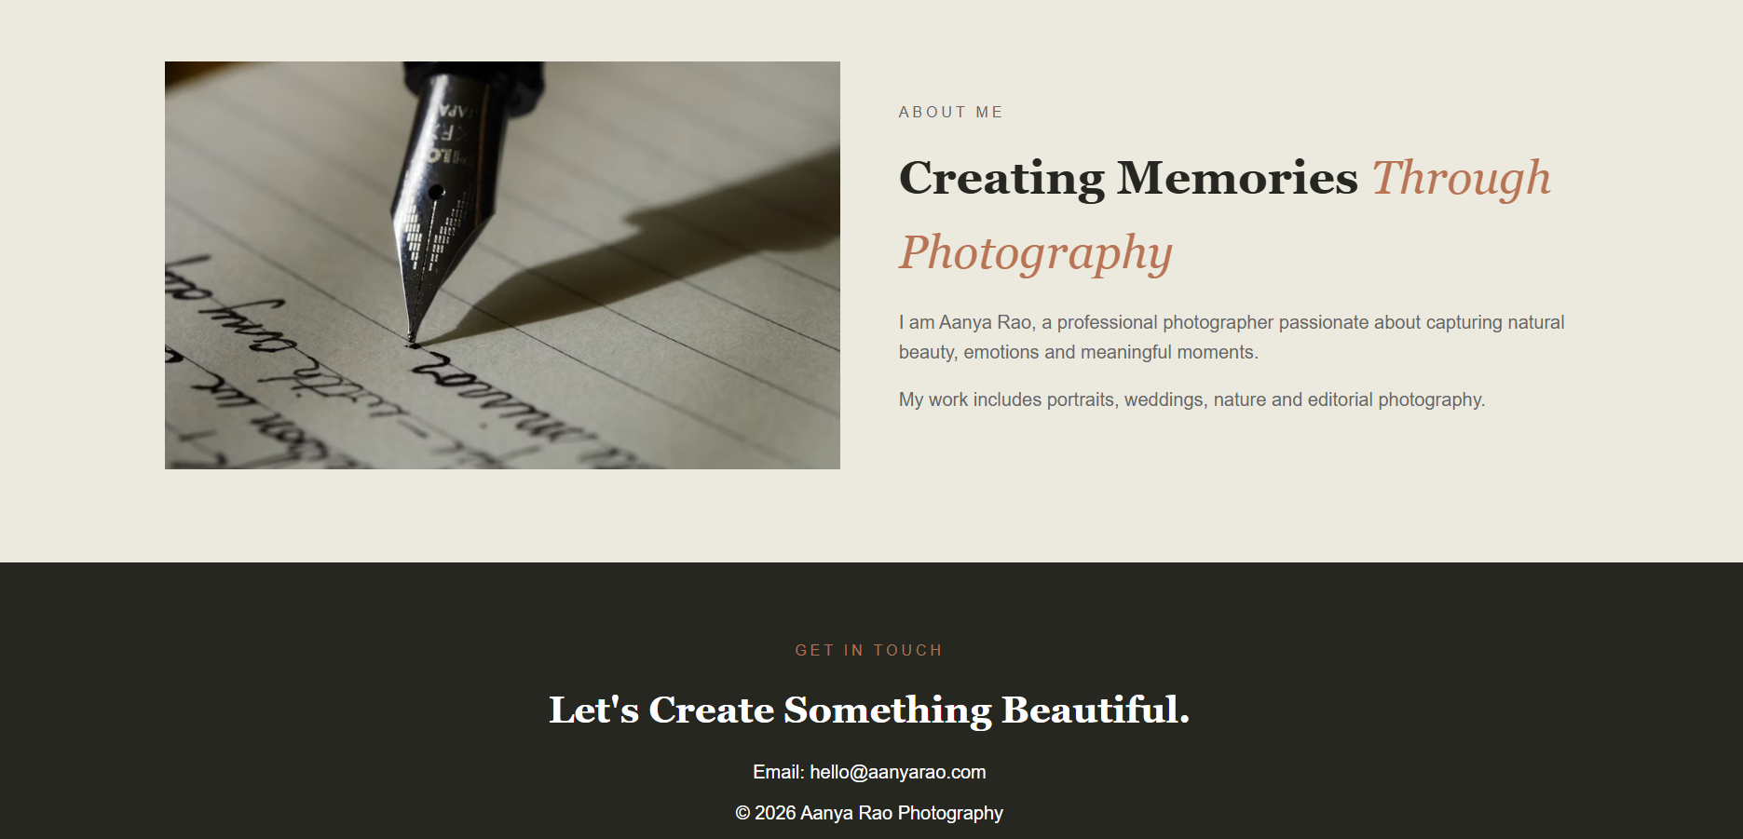

3. Using a GoDaddy Website Template as a Reference, Explain How CSS3 Features Are Used to Design Modern Web Pages. Discuss Backgrounds, Border Images, Colors, Shadows and Text Effects with Suitable CSS Code Examples.

Introduction
CSS3 is an advanced version of CSS that provides modern styling features. It helps developers create attractive, responsive and interactive websites.
Website templates provided by GoDaddy can be used as design references for creating professional business websites, portfolios and online stores.

Important CSS3 Features

1. CSS3 Backgrounds
CSS3 allows developers to apply background colors, images, gradients and multiple backgrounds.
Background Color:
body {
background-color: lightblue;
}
Background Image:
body {
background-image: url("background.jpg");
background-size: cover;
background-repeat: no-repeat;
background-position: center;
}
Linear Gradient:
.banner {
background: linear-gradient(
to right,
blue,
purple
);
}
Uses:
- Website banners.
- Hero sections.
- Product backgrounds.
- Attractive landing pages.

2. CSS3 Border Images
The border-image property allows an image to be used as an element's border.
Example:
div {
border: 15px solid transparent;

border-image-source: url("border.png");
border-image-slice: 30;
border-image-repeat: stretch;
}
Uses:
- Decorative photo frames.
- Special content boxes.
- Creative website layouts.

3. CSS3 Colors
CSS3 supports different color formats.
Named Colors:
h1 {
color: red;
}
RGB Colors:
p {
color: rgb(255, 0, 0);
}
RGBA Colors:
div {
background-color: rgba(0, 0, 255, 0.5);
}
HEX Colors:
body {
background-color: #f0f0f0;
}
HSL Colors:
h1 {
color: hsl(240, 100%, 50%);
}

4. CSS3 Shadows
CSS3 provides shadow effects to create depth and visual appearance.
Box Shadow:
.card {
width: 250px;
padding: 20px;

box-shadow: 5px 5px 10px gray;
}
Text Shadow:
h1 {
text-shadow: 3px 3px 5px gray;
}
Uses:
- Product cards.
- Navigation bars.
- Buttons.
- Headings and banners.

5. CSS3 Text Effects
CSS3 provides different properties to improve text appearance.
Text Overflow:
p {
width: 200px;
white-space: nowrap;
overflow: hidden;
text-overflow: ellipsis;
}
Word Wrapping:
p {
overflow-wrap: break-word;
}
Text Decoration:
h2 {
text-decoration: underline;
}
Text Transform:
h1 {
text-transform: uppercase;
}

6. Example of a Modern Website Design
<!DOCTYPE html>
<html>
<head>
<title>Modern Website</title>

<style>
body {
margin: 0;
font-family: Arial;
background: linear-gradient(
to right,
#3498db,
#8e44ad
);
}

header {
color: white;
text-align: center;
padding: 40px;
text-shadow: 2px 2px 4px black;
}

.card {
background: white;
width: 300px;
margin: auto;
padding: 25px;
border-radius: 15px;
box-shadow: 5px 5px 15px gray;
text-align: center;
}

button {
background-color: blue;
color: white;
padding: 10px 20px;
border: none;
border-radius: 5px;
}
</style>
</head>

<body>

<header>
<h1>Welcome to My Website</h1>
</header>

<div class="card">
<h2>Our Services</h2>
<p>We create modern websites.</p>
<button>Explore</button>
</div>

</body>
</html>

Advantages of CSS3
- Creates attractive website designs.
- Supports gradients and background images.
- Provides shadows and text effects.
- Improves visual appearance.
- Reduces the need for external graphics.
- Supports modern responsive web design.

Conclusion
CSS3 provides powerful styling features for modern website development. Backgrounds, border images, colors, shadows and text effects help create professional and user-friendly websites similar to modern GoDaddy website templates.
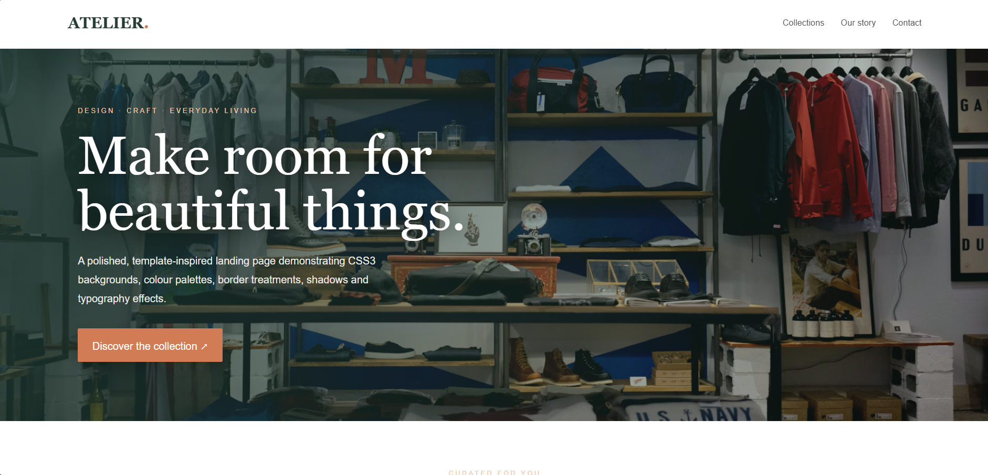

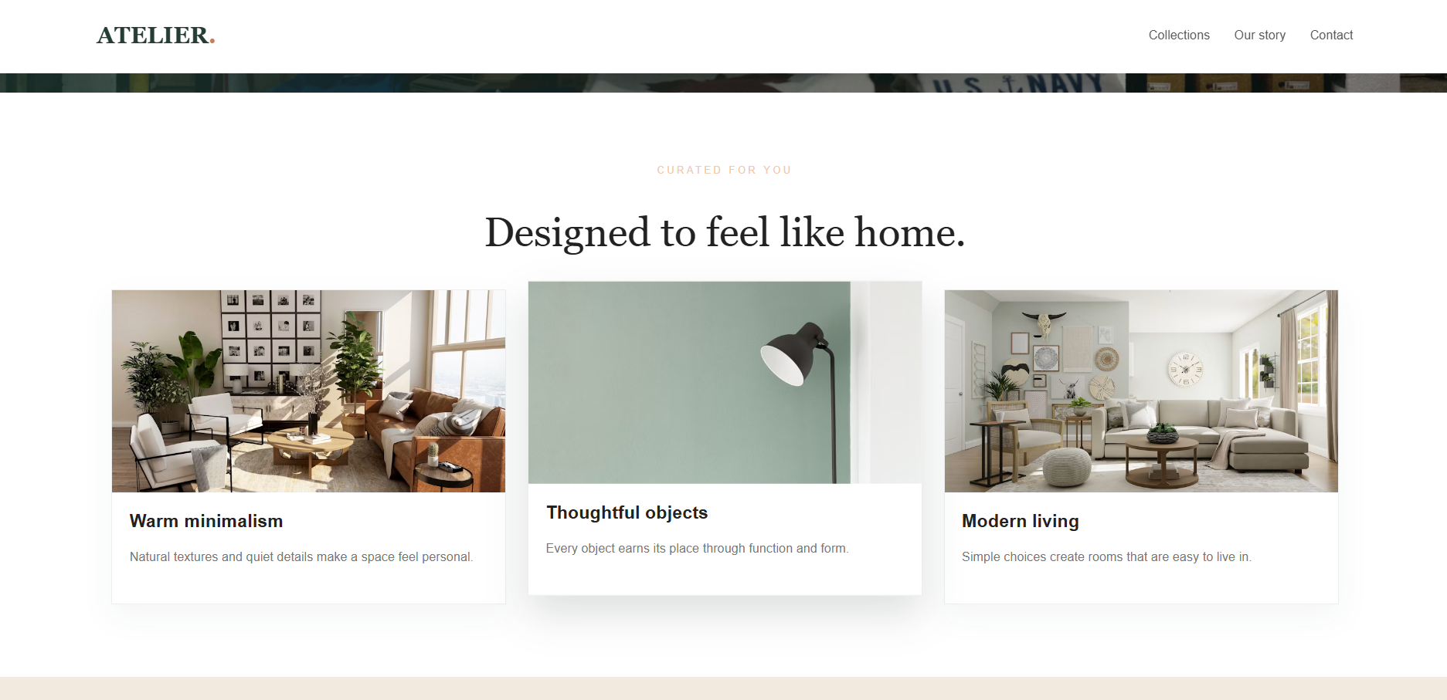

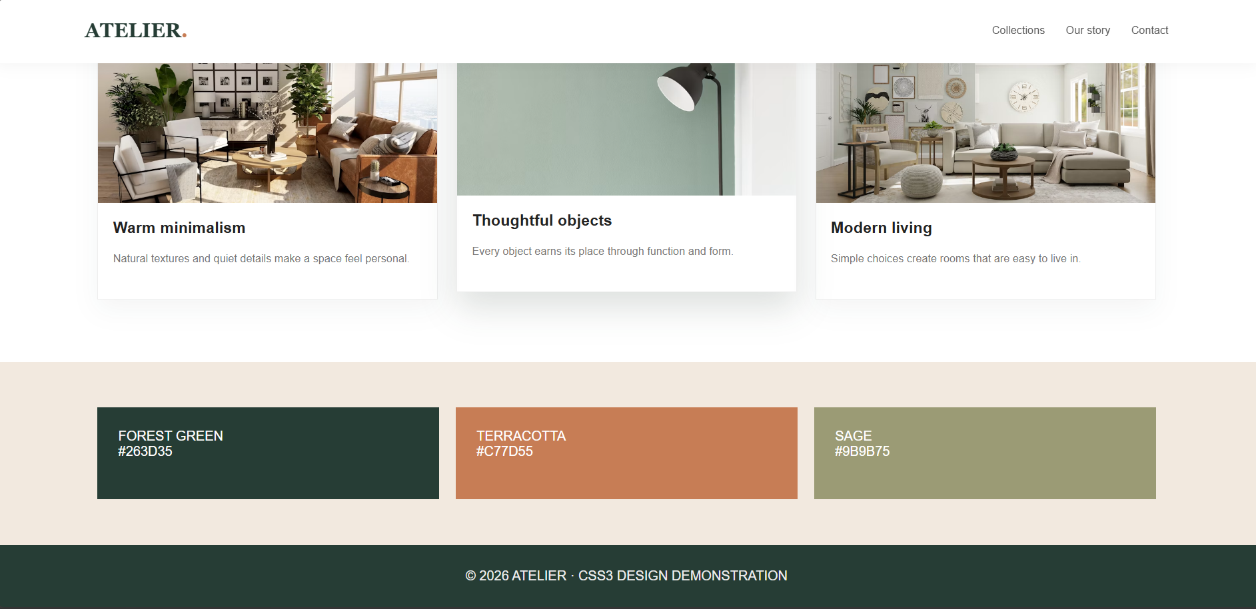

4. Design a Contemporary Web Page with Implementation of CSS3 Transformations, Transitions and Animations (Marquee) with Different Types of Transformations and Demonstrate How Animations Can Be Implemented Using Keyframes.

Introduction
CSS3 provides transformations, transitions and animations to create interactive and attractive webpages.
These features improve the user experience by adding movement, visual effects and smooth changes to webpage elements.

1. CSS3 Transformations
The transform property is used to change the position, size, rotation and shape of an element.
Different types of transformations:
A. Translate
Moves an element from one position to another.
.box {
transform: translate(50px, 20px);
}
B. Rotate
Rotates an element around a point.
.box {
transform: rotate(45deg);
}
C. Scale
Increases or decreases the size of an element.
.box {
transform: scale(1.5);
}
D. Skew
Tilts an element along the X or Y axis.
.box {
transform: skew(20deg, 10deg);
}
E. Multiple Transformations
Multiple transformations can be applied together.
.box {
transform: translate(20px, 10px)
rotate(30deg)
scale(1.2);
}

2. CSS3 Transitions
Transitions allow CSS property changes to happen smoothly over a specified time.
Example:
button {
background-color: blue;
color: white;
padding: 15px;
transition: background-color 1s;
}

button:hover {
background-color: red;
}
When the user moves the mouse over the button, its background changes smoothly from blue to red.
Important transition properties:
- transition-property
- transition-duration
- transition-timing-function
- transition-delay

3. CSS3 Animations
CSS animations allow elements to change styles automatically without requiring user interaction.
Animations are created using the @keyframes rule.
Example:
.box {
width: 100px;
height: 100px;
background-color: red;

animation: move 4s infinite;
}

@keyframes move {
0% {
transform: translateX(0);
}

50% {
transform: translateX(200px);
}

100% {
transform: translateX(0);
}
}
The box moves from its original position to the right and returns continuously.

4. CSS3 Marquee Animation
A marquee is used to move text horizontally or vertically across a webpage.
Example:
<!DOCTYPE html>
<html>
<head>
<title>Marquee Animation</title>

<style>
.marquee {
width: 100%;
overflow: hidden;
white-space: nowrap;
}

.marquee span {
display: inline-block;

animation: scroll 10s linear infinite;
}

@keyframes scroll {
from {
transform: translateX(100%);
}

to {
transform: translateX(-100%);
}
}
</style>
</head>

<body>

<div class="marquee">
<span>Welcome to Our Modern Website!</span>
</div>

</body>
</html>
The text continuously moves from right to left.

5. Complete Contemporary Webpage Example
<!DOCTYPE html>
<html>
<head>
<title>Modern Web Design</title>

<style>

body {
font-family: Arial;
text-align: center;
background-color: lightgray;
}

header {
background-color: navy;
color: white;
padding: 30px;
}

.box {
width: 150px;
height: 150px;
background-color: orange;
margin: 50px auto;

transition: transform 1s;
}

.box:hover {
transform: rotate(45deg) scale(1.2);
}

button {
padding: 15px 25px;
background-color: blue;
color: white;
border: none;

transition: background-color 1s;
}

button:hover {
background-color: green;
}

.animation {
width: 100px;
height: 100px;
background-color: red;
margin: 30px auto;

animation: example 3s infinite;
}

@keyframes example {
0% {
transform: translateX(0);
}

50% {
transform: translateX(100px);
}

100% {
transform: translateX(0);
}
}

</style>
</head>

<body>

<header>
<h1>Contemporary Web Design</h1>
</header>

<h2>CSS Transformation</h2>
<div class="box"></div>

<h2>CSS Transition</h2>
<button>Hover Me</button>

<h2>CSS Animation</h2>
<div class="animation"></div>

</body>
</html>

Advantages
- Creates attractive web pages.
- Provides smooth visual effects.
- Improves user interaction.
- Reduces the need for JavaScript for simple animations.
- Makes websites more engaging.

Conclusion
CSS3 transformations, transitions and animations help developers create modern and interactive webpages. The @keyframes rule is particularly useful for creating continuous animations such as moving boxes, loading effects and marquee text.
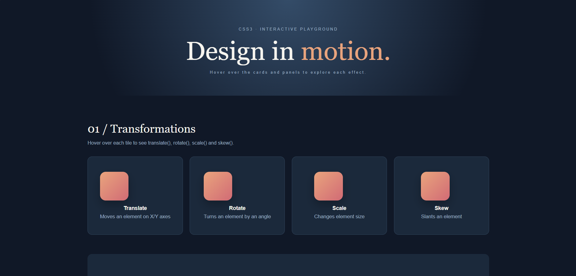

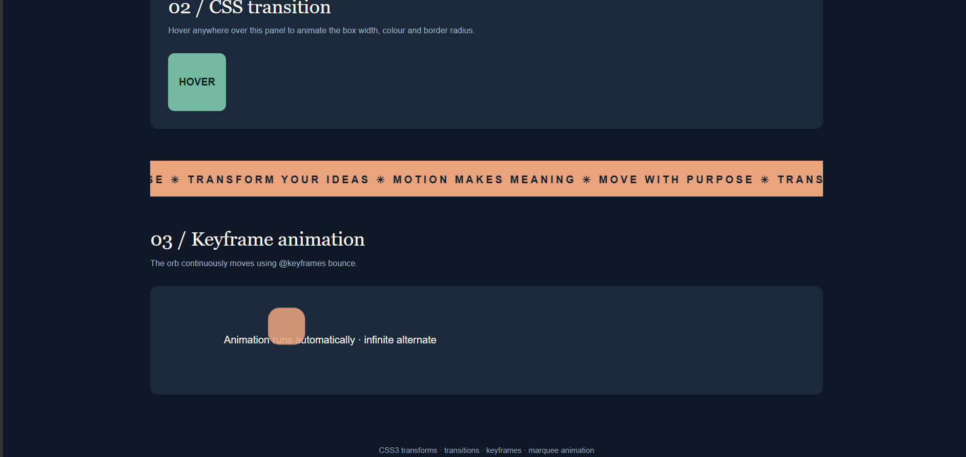

5. Design an Architecture, Features and Working Principles of Progressive Web Applications (PWA). Discuss the Roles of Service Workers, Web App Manifests, Caching Strategies and Push Notifications in Providing an Enhanced User Experience.

Introduction
A Progressive Web Application (PWA) is a type of web application that provides an app-like experience through a web browser.
PWA combines the advantages of websites and mobile applications. It can work offline, load quickly and can be installed on supported devices.
Examples of applications that have used PWA technology include Twitter Lite and Starbucks.

1. Architecture of PWA
The main components of PWA architecture are:
1. Frontend (User Interface)
- Developed using HTML, CSS and JavaScript.
- Displays the application content.
- Allows users to interact with the application.
2. Web Server
- Stores website files.
- Provides application resources.
- Communicates with the browser.
3. Service Worker
- Works in the background.
- Handles network requests.
- Supports offline functionality.
- Manages caching and push notifications.
4. Web App Manifest
- Provides application information.
- Defines the application name, icons and theme color.
- Helps users install the application.
5. Cache Storage
- Stores important files and resources.
- Allows the application to load without an internet connection.

PWA Architecture Diagram

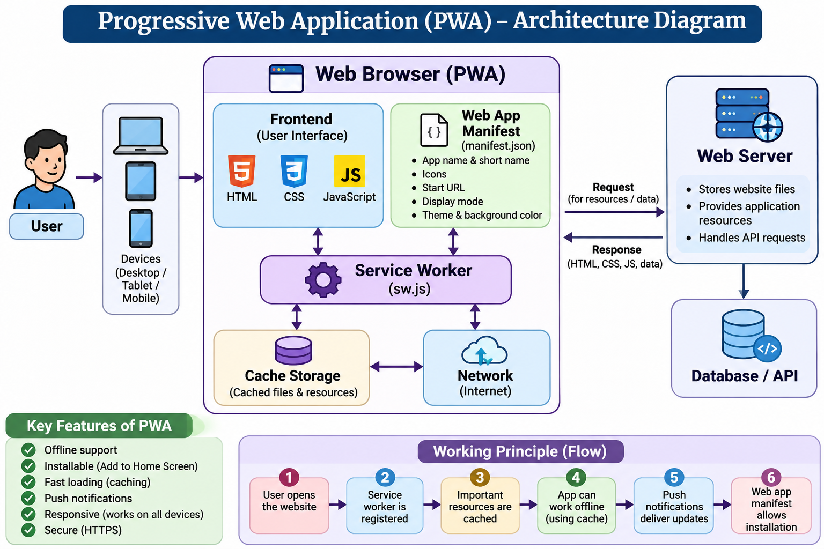

2. Important Features of PWA
1. Offline Support
PWA can work without an internet connection using cached resources.
2. Installability
Users can install the application on supported devices without downloading it through a traditional app store.
3. Responsive Design
PWA works on desktops, tablets and smartphones.
4. Fast Loading
Caching improves performance and reduces loading time.
5. Push Notifications
PWA can send notifications to users even when the website is not currently open, subject to browser and platform support.
6. Secure Connection
PWA requires HTTPS for service workers and other powerful features, with localhost generally allowed for development.

3. Role of Service Workers
A service worker is a JavaScript file that runs in the background, separate from the webpage.
Main functions:
- Intercepts network requests.
- Caches website resources.
- Provides offline support.
- Handles push notifications.
- Improves website performance.
Example:
if ('serviceWorker' in navigator) {

navigator.serviceWorker.register('sw.js')
.then(function() {
console.log("Service Worker Registered");
})
.catch(function(error) {
console.log(error);
});

}
This code registers a service worker in the browser.

4. Role of Web App Manifest
A web app manifest is a JSON file that provides information about the application.
It contains:
- Application name.
- Short name.
- Application icons.
- Start URL.
- Display mode.
- Theme color.
- Background color.
Example:
{
"name": "My PWA Application",
"short_name": "MyPWA",
"start_url": "/",
"display": "standalone",
"background_color": "#ffffff",
"theme_color": "#0000ff",
"icons": [
{
"src": "icon.png",
"sizes": "192x192",
"type": "image/png"
}
]
}
The manifest is connected to HTML using:
<link rel="manifest" href="manifest.json">

5. Caching Strategies
Caching stores website resources so that they can be accessed quickly.
Important caching strategies include:
1. Cache First
- Checks the cache first.
- If the resource is available, it is returned from the cache.
- Otherwise, it requests the resource from the network.
Useful for static files such as images, CSS and JavaScript.
2. Network First
- Tries to fetch data from the network first.
- If the network fails, it uses cached data.
Useful for news and frequently updated content.
3. Stale While Revalidate
- Immediately returns cached content.
- Fetches an updated version from the network in the background.
- Updates the cache for future requests.
Useful for frequently viewed content.
4. Network Only
- Always requests resources from the network.
- Does not use cached responses.
Useful for operations requiring fresh network data.
5. Cache Only
- Retrieves resources only from the cache.
- Does not access the network.
Useful for resources that are already stored.

6. Push Notifications
Push notifications allow applications to send messages to users.
Examples:
- New messages.
- Order updates.
- Special offers.
- Important announcements.
Working process:
- The user gives permission for notifications.
- The browser creates a push subscription.
- The subscription is sent to the application server.
- The server sends a push message through a push service.
- The service worker receives the push event.
- The browser displays the notification.
Example:
self.addEventListener('push', function(event) {

const options = {
body: 'You have a new notification!',
icon: 'icon.png'
};

event.waitUntil(
self.registration.showNotification(
'My PWA',
options
)
);

});

7. Working Principles of PWA
The working process can be explained step by step:
Step 1: The user opens the website through a browser.
Step 2: The browser downloads HTML, CSS and JavaScript files.
Step 3: The service worker is registered.
Step 4: Important website resources are stored in cache storage.
Step 5: The web app manifest provides installation information.
Step 6: When the user revisits the application, cached resources can provide faster loading and offline access.
Step 7: Push notifications can deliver updates when users have subscribed and granted permission.

Advantages of PWA
- Works on multiple devices.
- Supports offline access.
- Loads quickly.
- Can be installed on supported devices.
- Provides push notifications.
- Reduces repeated network requests.
- Provides an app-like user experience.

Conclusion
Progressive Web Applications are an important technology in modern web development. Service workers, web app manifests, caching strategies and push notifications work together to provide fast, reliable and engaging applications. PWAs combine the accessibility of websites with many features of mobile applications.


